# CS 255 System Design Document

## UML Diagrams

### UML Use Case Diagram

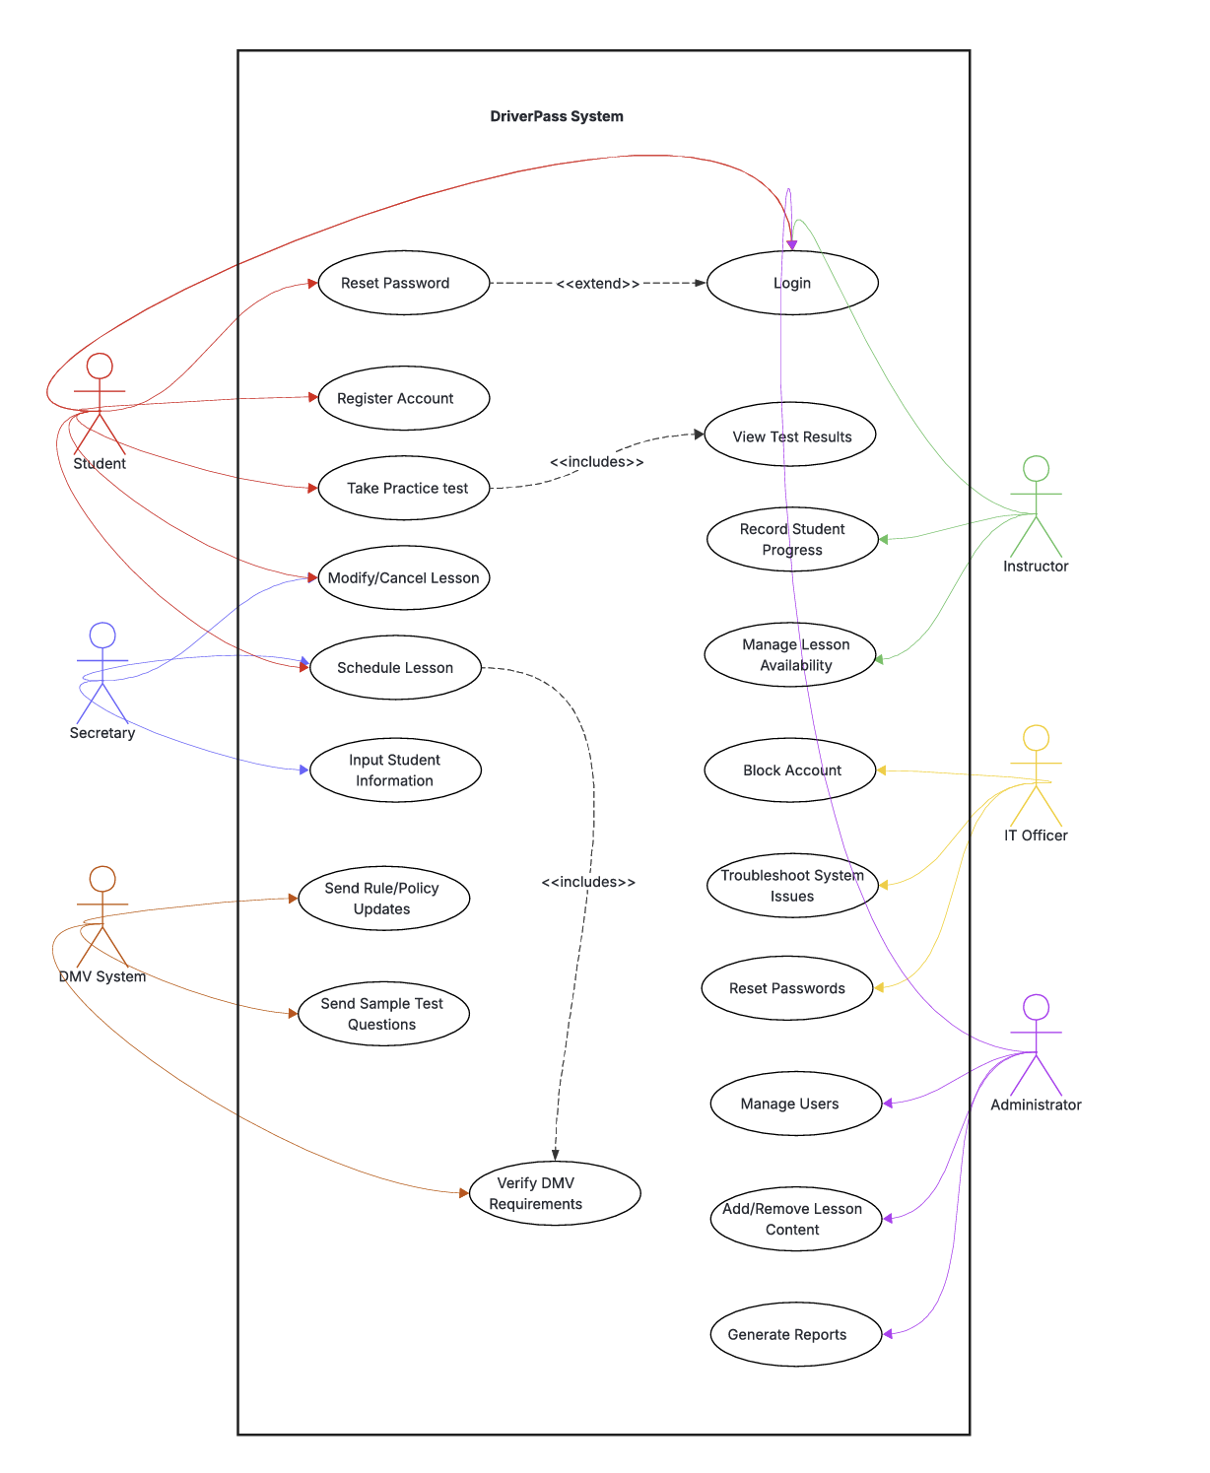

### UML Activity Diagrams

Schedule Lesson Take Practice Test

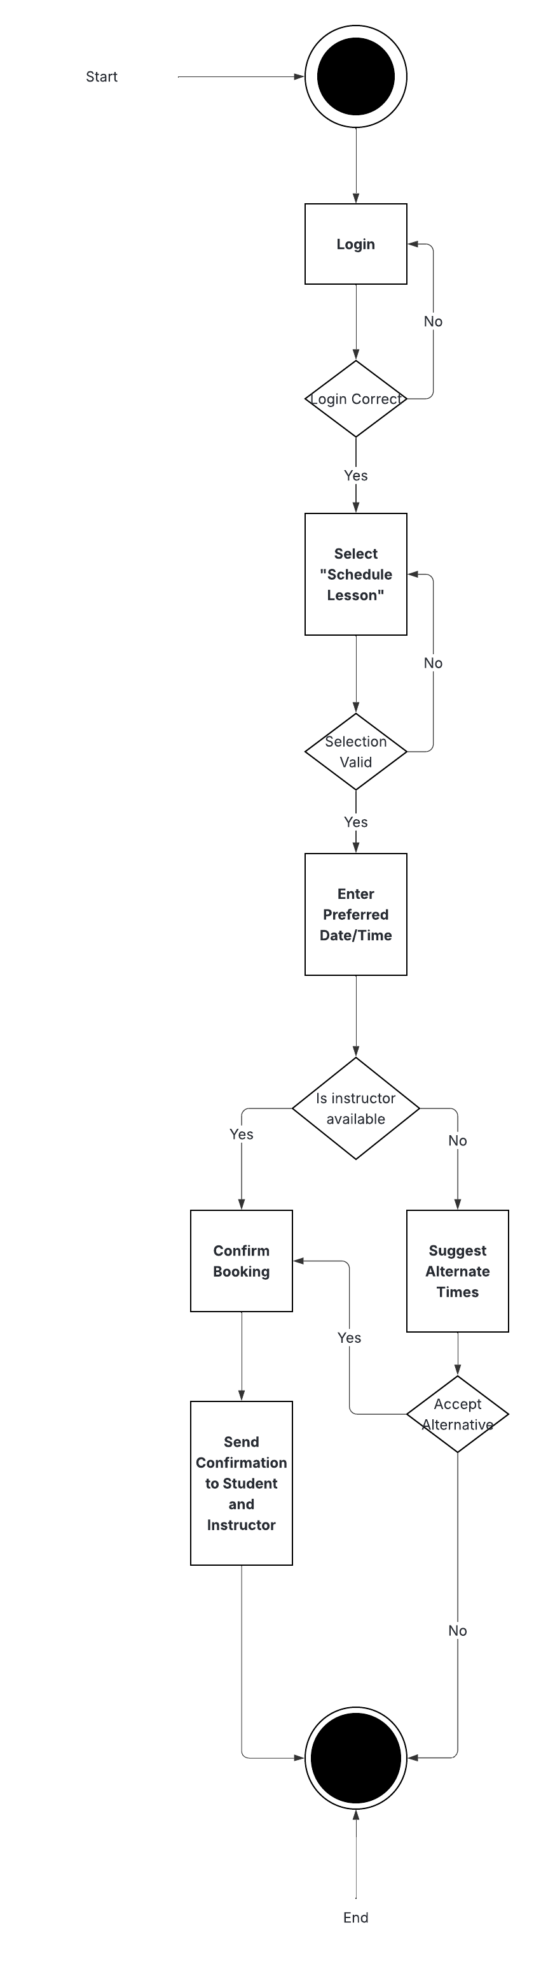 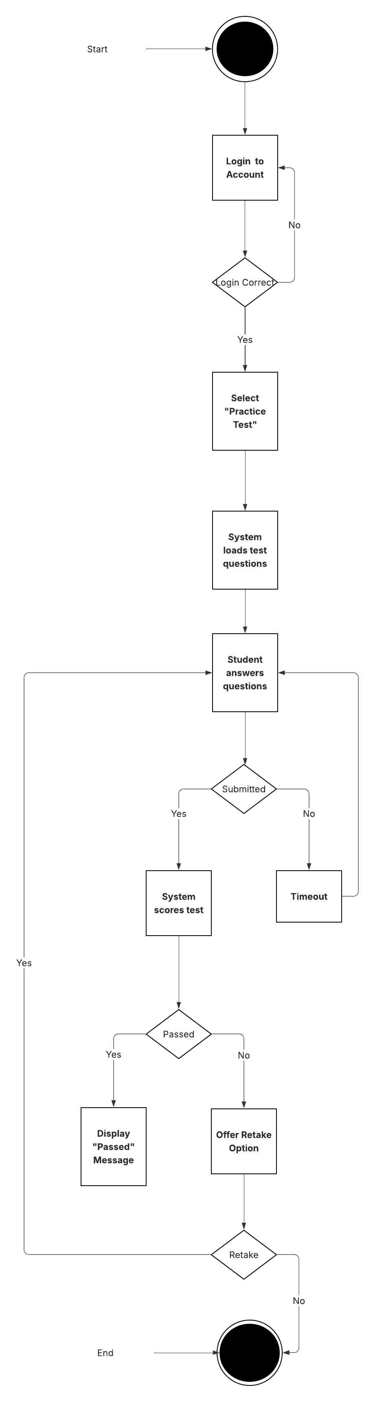

### UML Sequence Diagram

### UML Class Diagram

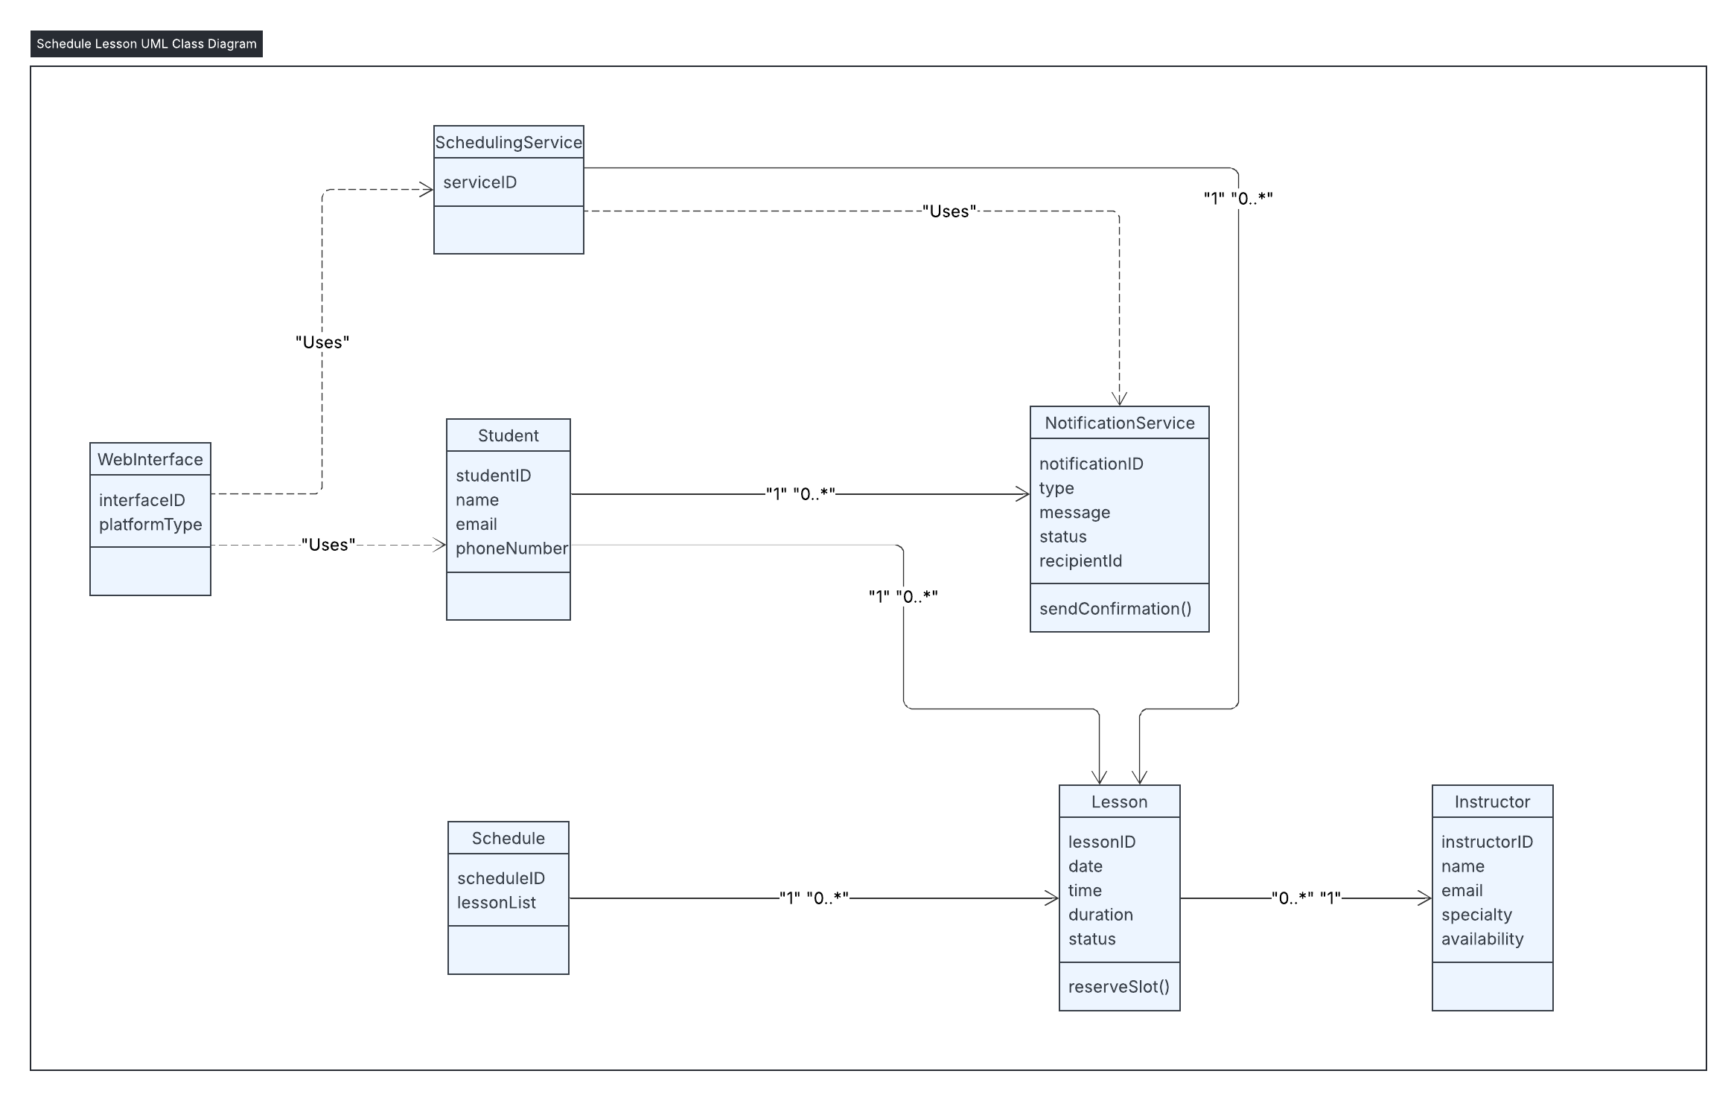

## Technical Requirements

***1. Hardware Requirements***

| ***Component*** | ***Requirement*** | ***Description*** |
| --- | --- | --- |
| ***Client Devices*** | *PC, Laptop, Tablet, or Smartphone* | *Students need devices capable of running a modern web browser or mobile app.* |
| ***Server*** | *Multi-core CPU, 16 GB+ RAM, SSD storage* | *Hosts the Scheduling Service, Instructor Database, and Notification Service. Should handle concurrent lesson bookings.* |
| ***Network*** | *Stable high-speed internet* | *For real-time communication between client devices and server.* |

***2. Software Requirements***

| ***Component*** | ***Requirement*** | ***Description*** |
| --- | --- | --- |
| ***Operating System*** | *Windows Server, Linux (Ubuntu/CentOS)* | *Server OS to host backend services.* |
| ***Web Browser / Mobile OS*** | *Chrome, Firefox, Edge, iOS, Android* | *Clients need modern browsers or mobile OS to access WebInterface.* |
| ***Database*** | *MySQL / PostgreSQL / MongoDB* | *Stores Student, Instructor, Lesson, and Schedule data.* |
| ***Backend Framework*** | *Java Spring Boot / Node.js / Django* | *Implements SchedulingService logic and handles API requests.* |
| ***Notification Service*** | *SMTP server or third-party API (Twilio, SendGrid)* | *Sends email or SMS confirmations to students.* |

***3. Tools***

| ***Tool*** | ***Purpose*** |
| --- | --- |
| ***Lucidchart / UML Tool*** | *Design and document UML diagrams (Use Case, Sequence, Class).* |
| ***IDE / Code Editor*** | *Visual Studio Code, IntelliJ IDEA, PyCharm, etc., for system development.* |
| ***Version Control*** | *Git / GitHub* |
| ***Testing Tools*** | *Postman / JUnit / Selenium* |

***4. Infrastructure Requirements***

| ***Component*** | ***Requirement*** | ***Description*** |
| --- | --- | --- |
| ***Web Server*** | *Apache, Nginx, or equivalent* | *Hosts the WebInterface and API endpoints.* |
| ***Database Server*** | *Dedicated DB instance or cloud-managed DB* | *Ensures data storage, retrieval, and backups.* |
| ***Cloud / Hosting (Optional)*** | *AWS, Azure, or GCP* | *Scalable infrastructure for deployment and high availability.* |
| ***Security*** | *SSL/TLS, Authentication, Authorization* | *Protects user data and ensures secure lesson bookings.* |

***5. Summary***

The system requires client devices with web or mobile access, a robust backend with a database and scheduling logic, and notification capability for confirmations. Development and deployment tools should support UML design, coding, testing, and secure hosting.